**UV-K5(8) UV-K6固件操作说明书**

UV-K5(8) UV-K6 Firmware operation manual

1. 准备工作

1.1安装固件升级软件“QSPSUpdater_Setup”。

1.2安装双插USB2102写频线驱动“CP210x_USB”。

注：不同厂商生产双插USB写频线驱动不同，需对应驱动安装。

1. Prep

1.1 Installing the Firmware upgrade software QSPSUpdater_Setup.

1.2 Installing the CP210x_USB write frequency driver with two slots in the USB2102.

Note: The dual-plug USB write frequency cable drivers produced by different manufacturers vary. Install the drivers accordingly.

1. 固件升级软件使用操作

2.1首先双插USB2102写频线插入电脑USB口，此时检查电脑的“设备管理器”查看端口连接后的COM号。如图显示：双插USB2102写频线正常连接，端口为COM3

2. Use the firmware upgrade software

2.1 First, double plug the USB2102 write frequency cable into the USB port of the computer. Then, check the Device Manager of the computer to check the COM number after the port is connected.As shown in the figure, the dual-plug USB2102 write frequency cable is connected normally, and the port is COM3

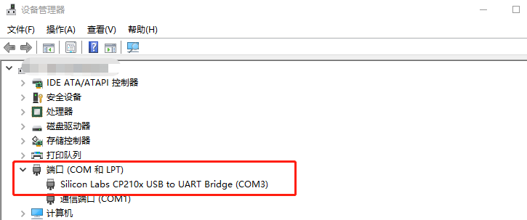

2.2点击应用程序进入固件升级界面

2.2 Tap Applications to go to the Firmware Upgrade page

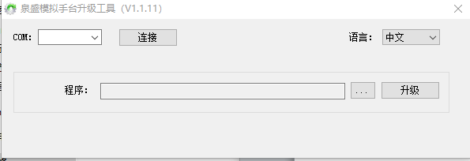

2.2.1首先COM栏选择COM3，点击连接。

2.2.2点击“…”找到K6固件包选择并打开。

2.2.3“语言”该功能为软件界面语言显示， “中文”“英文”两种。

2.2.1 First select COM3 in the COM bar and click Connect.

2.2.2 Click...Locate the K6 firmware package select and open it.

2.2.3 Language Indicates the language displayed on the software interface, which can be Chinese or English.

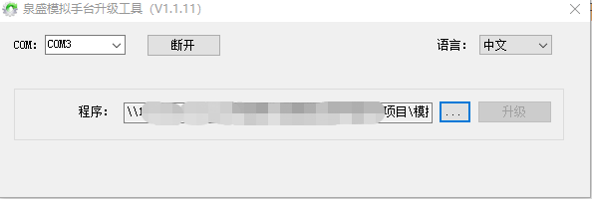

2.2.4手持台长按PTT键开机，手持台手电灯常亮（屏幕无显示），此时手持台已进入固

件升级模式，插入双插USB2102写频线，点击升级工具“升级”，升级过程中手持

台手电灯闪烁，升级完成时软件提示 “升级程序成功！”。

2.2.4 Hold down the PTT button to turn on the handheld platform. When the handheld lamp is steady on (no display on the screen), the handheld platform is fixed

In upgrade mode, insert the dual USB2102 write frequency cable, click the upgrade tool "Upgrade", and hold it during the upgrade process

The flashlight flashes, and the software prompts "Upgrade program success!" when the upgrade is completed..

